## Methodology Identifying 2018 Waterloo-affiliated OA output in Scopus

Data sources  
Scopus

Date of searching  
May 30, 2019

Search strategy

1. Identify Waterloo-affiliated publications in Scopus (Waterloo affiliation profiles for all affiliations to institution)

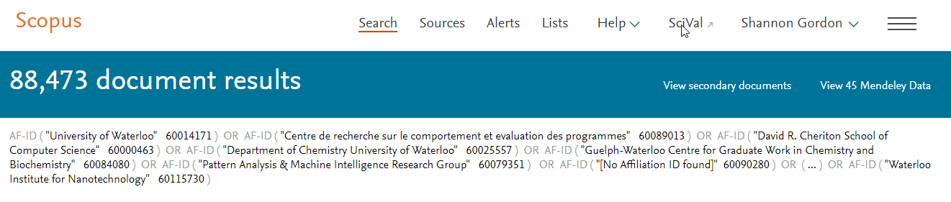

1. Within Scopus results, identify publications identified as 2018 and as OA:  
     
   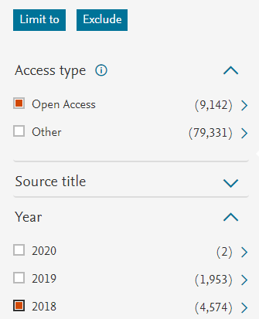  
     
   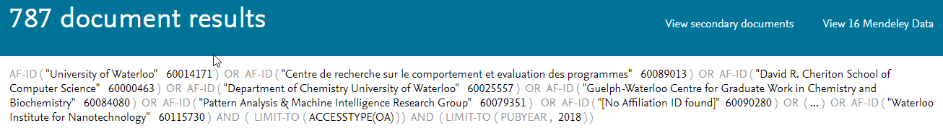
2. Exported results as CSV; saved as: *OA 2018 Scopus.csv*

**Note that Scopus definition for “Open Access” is: Gold/green (some) OA**